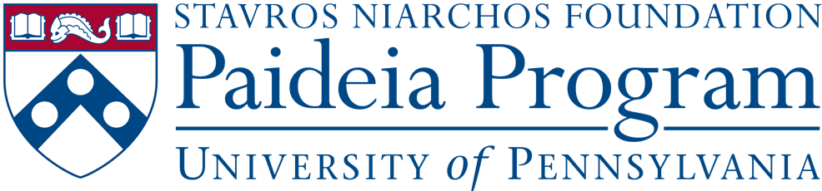

Small Grant Program Application
The small grant program hopes to incubate new ideas, pilot new programming and foster original research. After taking an SNF Paideia designated course, Penn undergraduates may be inspired to propose an event or program for the Penn community that fosters dialogue, citizenship, wellness and service. Alternately students might want to continue a research project they started in an SNF Paideia course. SNF Paideia Small Grant funding can be used for both programmatic ideas or to support individual research projects.

For students wanting to propose new events or programs, consultation is available from the SNF Paideia program for different steps of the implementation process (see SNF Paideia Event Planning Guides).

Students proposing independent research projects connected to an SNF Paideia course, need to have the support of the instructor of the SNF Paideia course that inspired their research project or that of another faculty or staff member at Penn. This faculty or staff member’s contact information will be asked for in the form below so we can confirm that they are aware of your request to have them supervise this project. Please make sure to contact them and get their approval before submitting your application.

Interested students will need to apply for funding using our application form below. It is suggested that students apply for funding at least 1 month in advance of their proposed project. Funded projects typically range from $250-$1000.

It is understandable that grantees might not have every aspect of their proposal figured out at the time of submission. Please indicate areas where you would like to consult with the SNF Paideia program before solidifying your proposal.

There are some things we do not fund, including:
- Equipment (though we are happy to connect you with Penn entities that rent out equipment)
- Ongoing projects (we might fund a pilot first episode of a podcast for example but not something that has no start and end date)
- Programming that primarily impacts a single student club without wider campus impact

Tell us about your programmatic idea and your budget needs by answering the questions below. Email your responses to Drs. Lia Howard (liaf@upenn.edu) and Leah Anderson (leahand@upenn.edu) to be considered for funding. Students who receive funding will submit a Grant Report and receipts documenting expenses upon completion of the funded project. Additional submission materials are welcome (e.g. a white paper, video submission or additional visual materials) but not required. The form below, however, is a requirement of funding.

- Please Indicate from the options below the type of project you are proposing:

- Research Project,
- Event,
- Other _____________________________________________

- Describe your proposed activity or research project and how it relates to one or more of the pillars of the SNF Paideia Program (Dialogue, Service, Citizenship, or Wellness).

- When and how do you propose to use the funds? Please give us your time line for the project.

- Please provide an itemized estimated budget below:

Expense | Amount | Notes

Total Requested Amount:

- Are you applying for/receiving funding from any other Penn entities? If yes, please identify them.

3. For Research Funding: Please list the faculty or staff members who are advising your project development and/or who will serve as mentors as you execute this research. Please list their name(s) and contact information here.

